MIDTOWNERS SUNSHINE OF THE WEEK ► October 5th, 2007
Birthday of Rtn. Prakash Bajracharya on October 2nd
Birthday of Rtn. Basu Dev Gautam on October 10th
Birthday of Pratima Shrestha, spouse of PP Gopal on October 10th
Birthday of Anu Pant, spouse of Rtn. Radhesh on October 10th

SPEAKER OF THE WEEK ► Shyam Raj Thapaliya
THEME | One possible and successful business approach in Nepal
This week, Mr. Shyam Raj Thapaliya will speak to us about how he set up a successful travel business in Nepal. Mr. Thapaliya is currently the Managing Director of Osho World Travel that he started in 1999. Previously, he held government job from 1985 to 1997, and was with King Mahendra Trust for Nature Conservation from 1997 to 1998.

UPCOMING SPEAKERS ► PREVIEW
DATE | SPEAKER | THEME
Oct 12th | PP William Ma | New Nepal District – Challenges and Opportunities
Oct 19th | Dashain – Maha Asthami | No Meeting
Oct 26th | Omni Acharya | TRF Peace Fellow

THE MID-TOWN CLUB ► NEWS
Last Week’s Talk
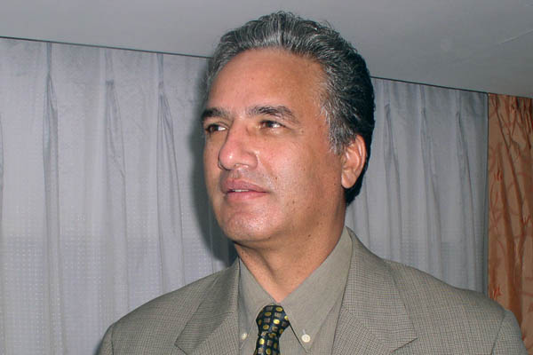
Dr. Som Pudasaini delivering his talk at our club

Dr. Som delivered an interesting talk about a very pertinent issue: Building a New Nepal. His talk touched upon factors that he thins are important if Nepal were to progress. He opined that there is a lack of post conflict planning, and Nepal to address ethnic and regional conflicts and to deal with the Maoists. There is also a need to reconstruct the infrastructure which has been destroyed during a decade of insurgency. Dr. Som also pointed out that democracy needs to be instilled at all levels and most notably within the internal politics of the political parties. He emphasised the need for very good international relations with its two superpower neighbours and with the US. One of Nepal’s greatest natural resources is its potential for tourism but in order to fully be able to exploit it stable politics is needed. Another area where Nepal needs to give serious thoughts is that of youth employment.

PAUL HARRIS FELLOW RECOGNITION
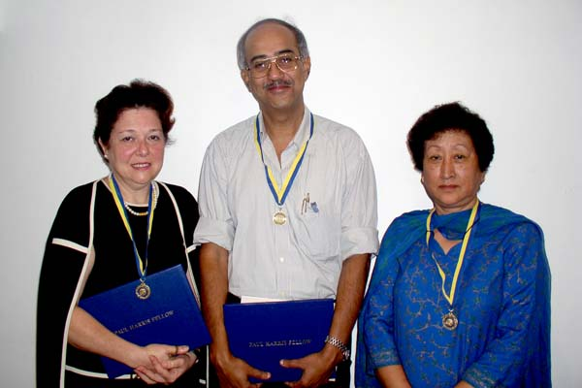
Three of our members Secretary Isa, Rtn. Anand, and PP Lekha (2nd PHF) were recognized for their PHF contribution at our regular meeting last week.
ROTARACT NEWS
Rotaract Sadhana Thapa of Kathmandu Mid-Town won yet another award, "The WWF NEpal Conservation Award 2007" in the category of "Matthew Preece and Yeshi Choden Lama Young Conservation Leader Award". The award recognizes young individuals for their dedicated and outstanding contribution to conservation for promotion of Kenaf plant in Nepal.
She is also the recepient of the 1st Century Youth Prize from Foundation for Encouragement of Social Contribution, Japan which was awarded on 20th November, 2006 in the presence of their Imperial Highness of Japan. She was the first and youngest to receive this prestigious award for organizing series of children program for the preservation of the beautiful nature of Nepal.
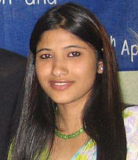

INETERACT/ROTARACT PROGRAM
On Sept 29th 2007, the Interacts of Kathmandu Mid-Town organized a free Gynecology and Dental Camp with the help of Jana Sewa School Family of Paanga. The program was supported by PP Dr Chandra Lekha Tuladhar and the Rotaracts of Kathmandu Mid-Town. Free toothpaste and brushes were also distributed to 200 patients. In spite of the heavy rainfall, a total of 250 patients in the dental section , and 85 in gynecology received check up.
Professional teams:
Dental Camp : Rtn Dr Budhhi Man Shrestha and his team from Kantipur school of Dentistry
Gynecology Camp : Dr Sushila Shrestha and her team

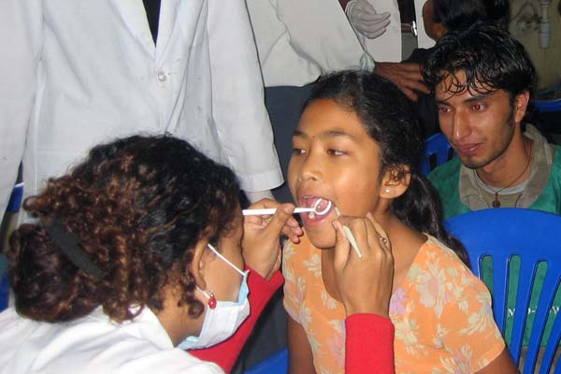  Kid getting Dental Check up | 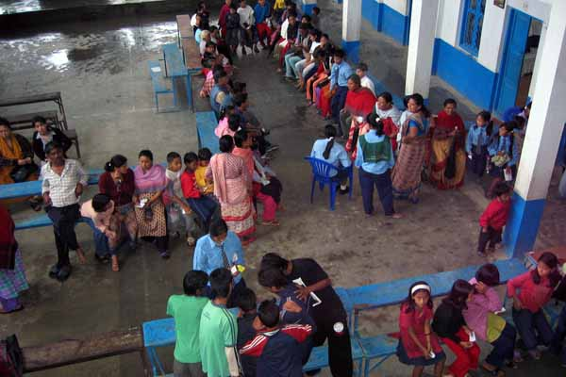  Patients lining up for Check up | 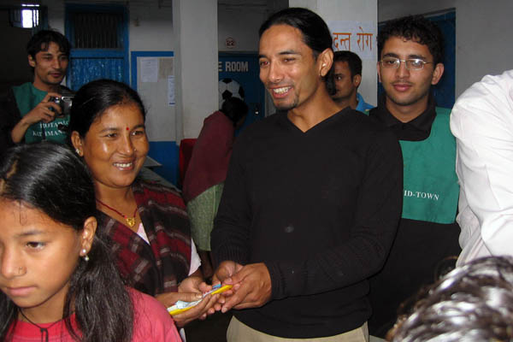  Rtn. Rabi handing out free toothbrush

Editor: Rabi Karmacharya, Club Service Director email: rabikarma@gmailcom

